Day 7 Revisit ( Java 11, 17 Features, Sealed Classes, NIO)

* New Methods in String class – isBlank(), strip(), lines(),
* New methods added in file handling
* ReadString() & WriteString()
* Collections toArray
* New way of running the java code (We can directly pass the java source code to jvm to execute it)
* OpenJDK , Merged JDK & JRE folder
* Exception Handling (Types of Exception)
* Exception Hierarchy (Throwable)
* Ways of Handling Exception (Using throws keyword, using try catch block)
* Runtime Exception (Unchecked Exception) and CompileTime Exception (Checked Exception)
* Types of try/catch block
* Try with finally
* Try with catch and finally
* Try with multiple catch block
* Keywords related to Exception Handling (try, catch, finally, throw, throws)
* Access & Non-access Modifier
* Sealed Classes (Introduced in Java15)
* Managing different versions of JDK (1.8,11,17) – Environment variable and path.
* Sealed class – Restricts no of class which can inherit it.
* Keywords related to sealed class (sealed, permits, non-sealed)
* The class which inherits sealed class should be final, sealed or non-sealed only.
* Pattern Matching (java.util.regex) – Regular Expression
* Pattern, Matcher, MatcherResult(I), PatternSyntaxException
* Searching, StringManipulation, Validations
* NIO & NIO2 – New streams, Local Variable,
* ByteStream, CharacterStream

Ref URL :

<https://docs.oracle.com/javase/8/docs/>

Agenda

* TDD (Test Driven Development)
* Junit 5
* Mockito
* SonarQube
* Lombok
* Logging
* NFR (Non Functional Requirement) – Performance Related

TDD – Test Driven Development

* Write the Test first even before starting application code.
* TDD ensures all the functionalities, requirements are taken care.
* Test cases will fail first.
* Write the application code to make the test pass.

TDD – is a software development practice that emphasizes writing tests before writing the actual code.

Test Driven Refactoring – It’s way(practice) of improving the application code.

JUNIT 5.

Official Site : <https://junit.org/junit5/>

Junit – Unit Testing framework for Java

**JUnit 5 = JUnit Platform + JUnit Jupiter + JUnit Vintage**

Junit Annotations

@Before

@Test

@BeforeEach

@BeforeClass

@After

@AfterEach

@AfterAll

Best Practice : Import needed code only (Class/Interface/Exception/Annotation)

Static Import – Importing static methods from a class

Testing – Manual & Automated Testing

Testing categories

* Unit Testing
* Integration Testing
* E2E Testing (End to End Testing)
* Performance Related Testing (Load Testing, Stress)
* Black box/White box/Sand box
* Acceptance Testing (UAT)

Why Testing

* To Ensure all the requirements are implemented
* To Ensure all the functionalities are implemented in expected way.

Env : Dev, Test, Pre-prod, UAT, Production

@Test

@ParameterizedTest

@DisplayName

Lombok - <https://projectlombok.org/>

Download the Lombok jar -- <https://projectlombok.org/download>

Install to IDE (Double click to install it)

@Data = For generating getters/setters, toString, hashcode()

@Getter = Generate getter method

Mockito -

Mock Objects (Test Double) /Dummy Objects

Recommended Package/folder structure (Project)

Com.sapient.tms (Base package) – Starter Class (Main method)

Com.sapient.tms.model/entity – All the Entity bean classes (Trainer/Company/SME)

Com.sapient.tms.util – DBUtil

Com.sapient.tms.repo (DAO) – Interfaces & for CRUD operation (readAll(), readById(), insert(), edit/update(), deleteById())

DAO – Data Access Object

DTO – Data Transfer Object

SUT – System Under Test

Mockito – Open Source Mock Testing Framework (Mocking framework) for Java based project

Mock/clone/test double/dummy object

Sonarqube – Static Code analysis – helps to write clean, efficient, vulnerability free code. – Code Smell

Sonarlint – Plugin that can be integrated with IDE

Adding sonarlint to IntelliJ – File🡪 Settings🡪 plugins (Search for sonarlint)

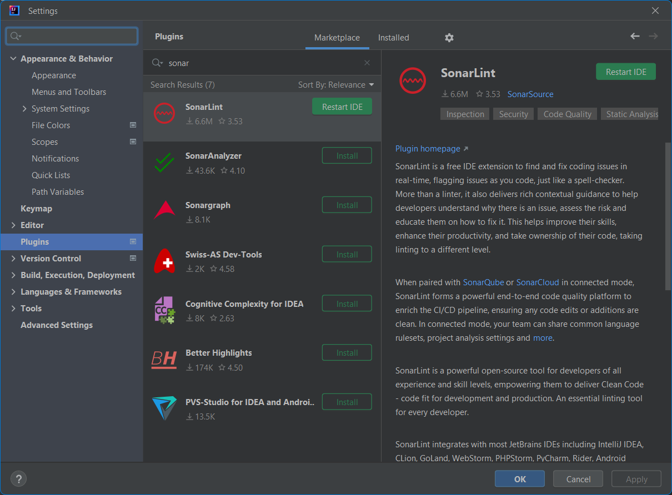

Running All test with coverage – In intellij IDE

Sonar Cloud -

Logging -- the act of keeping a log of events that occur in a computer system, such as problems, errors or just information on current operations

Logging – Java SE

Log4J, Logging for Java

SLF4J – Simple Logging Façade for Java

Log Messages – Date & Time Stamp – From Which Class/Function : Type of Message (Logging Level) – INFO, DEBUG, WARN, ERR